**Flight Management System using webflux and mongodb:**

**Jacoco Report:**

Code Coverage: 85%

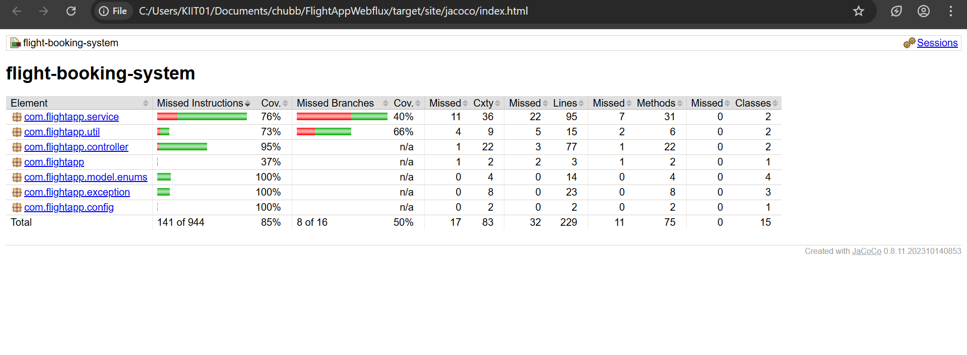

**SONARQUBE REPORT (Before):**

Code Coverage: 81.7

Total Issues: 11

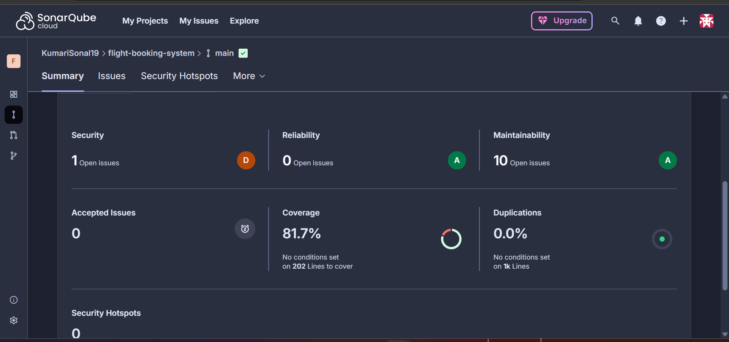

**ISSUES:**

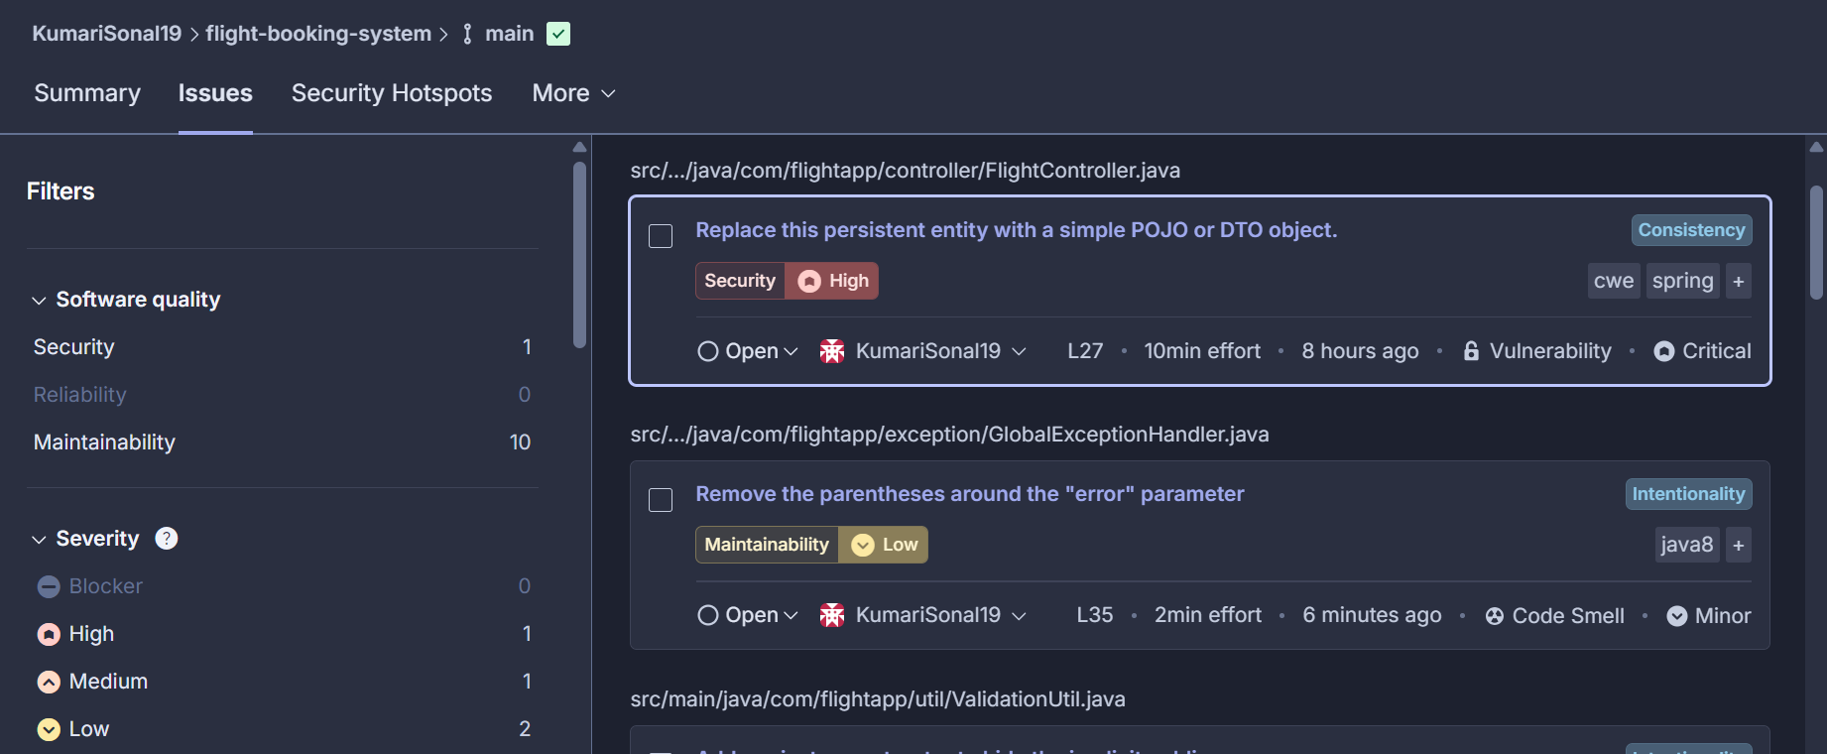

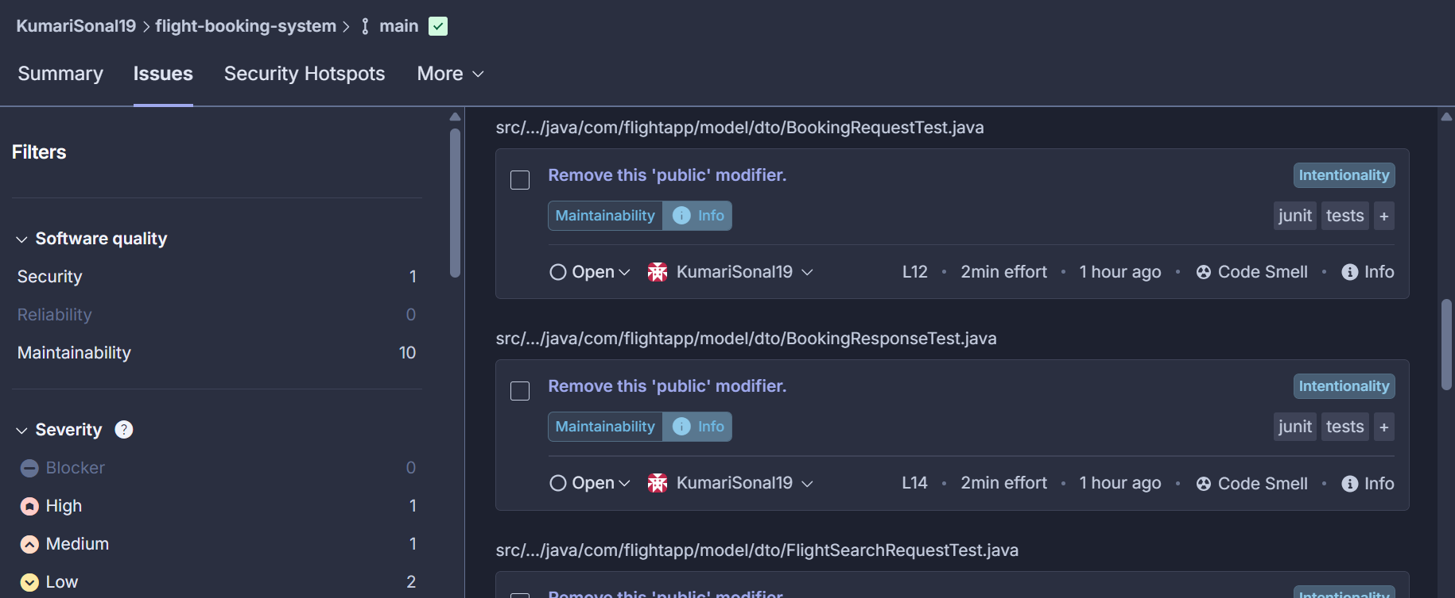

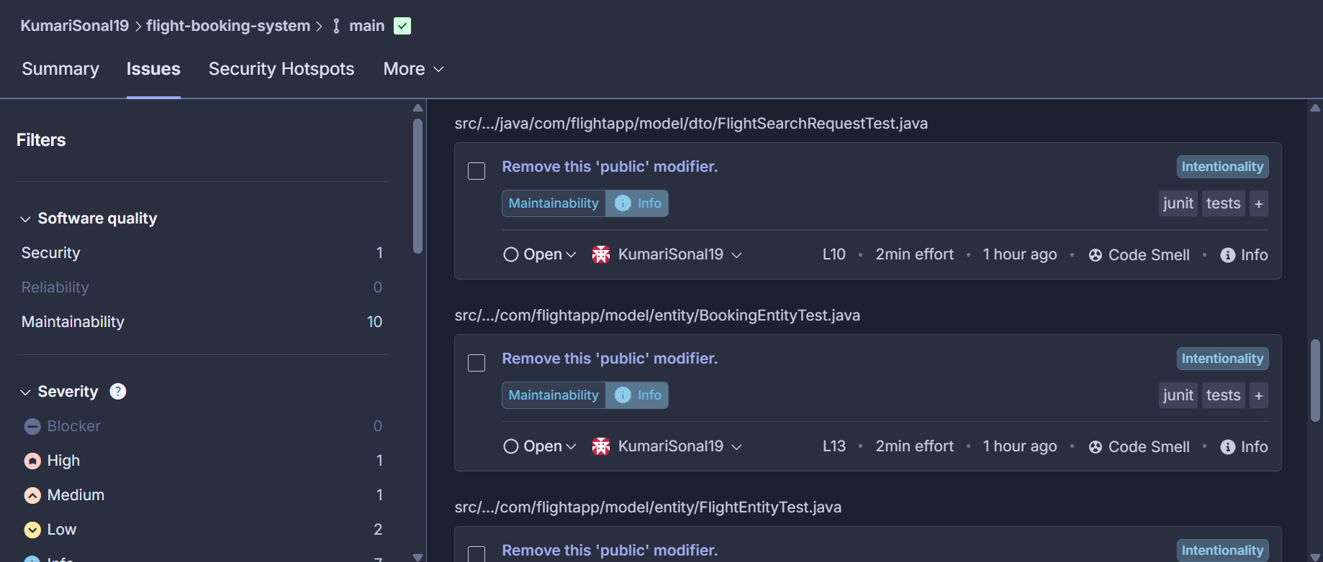

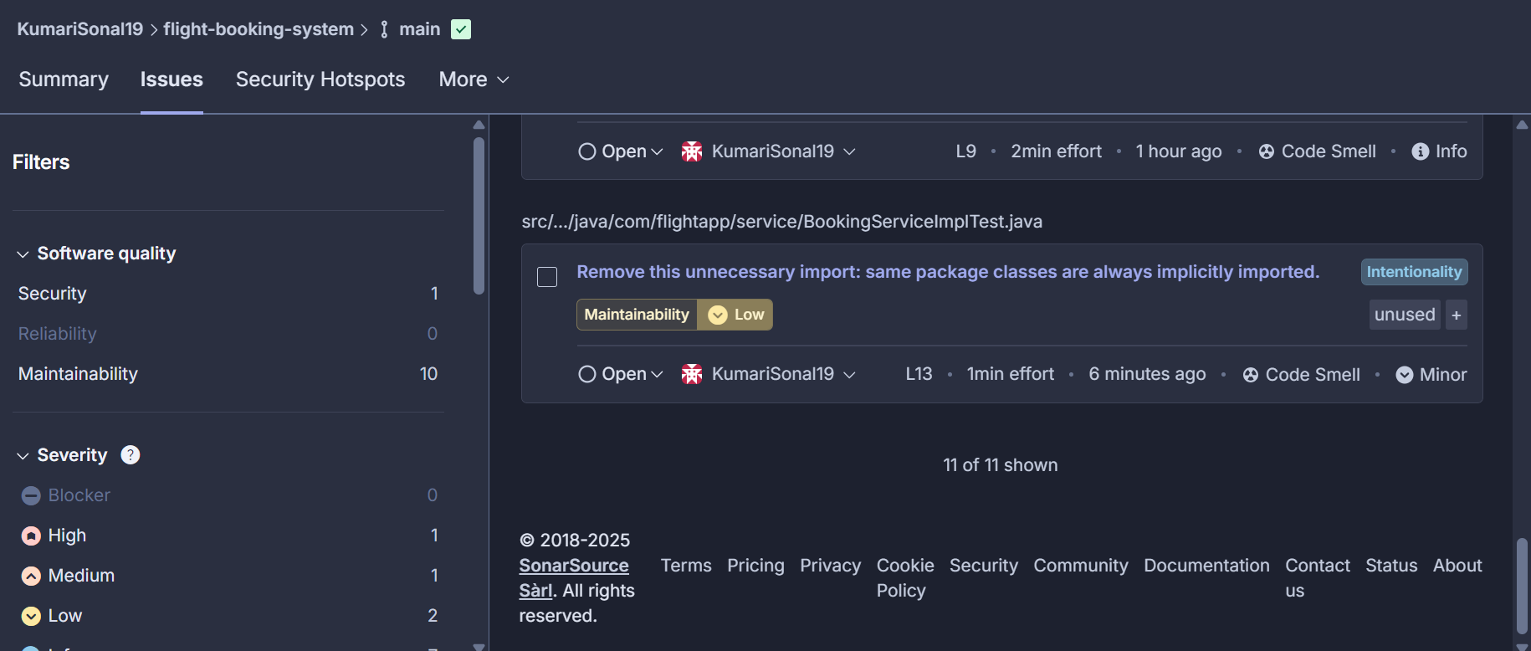

**SONARQUBE REPORT (After):**

All issues resolved

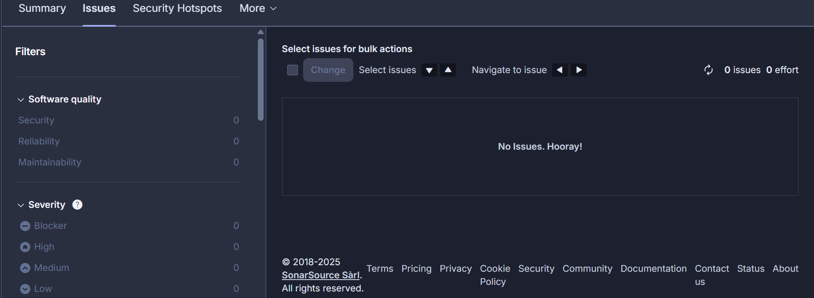

**JMETER TESTING**

Case 1: 20 requests  
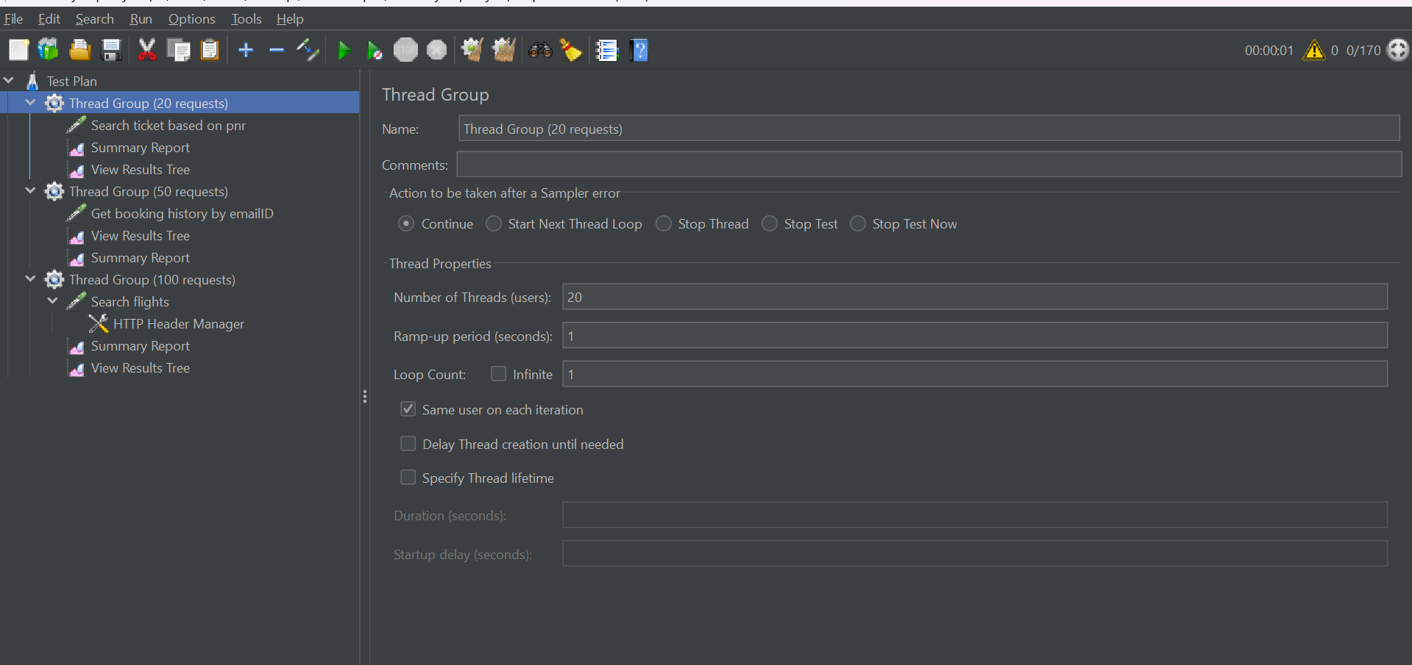

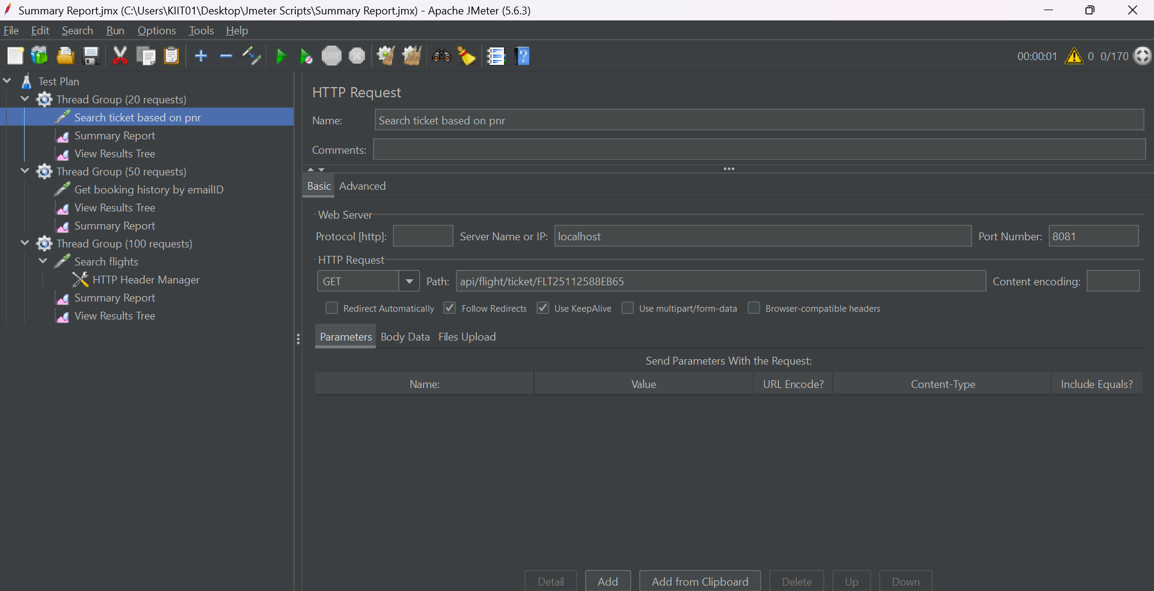

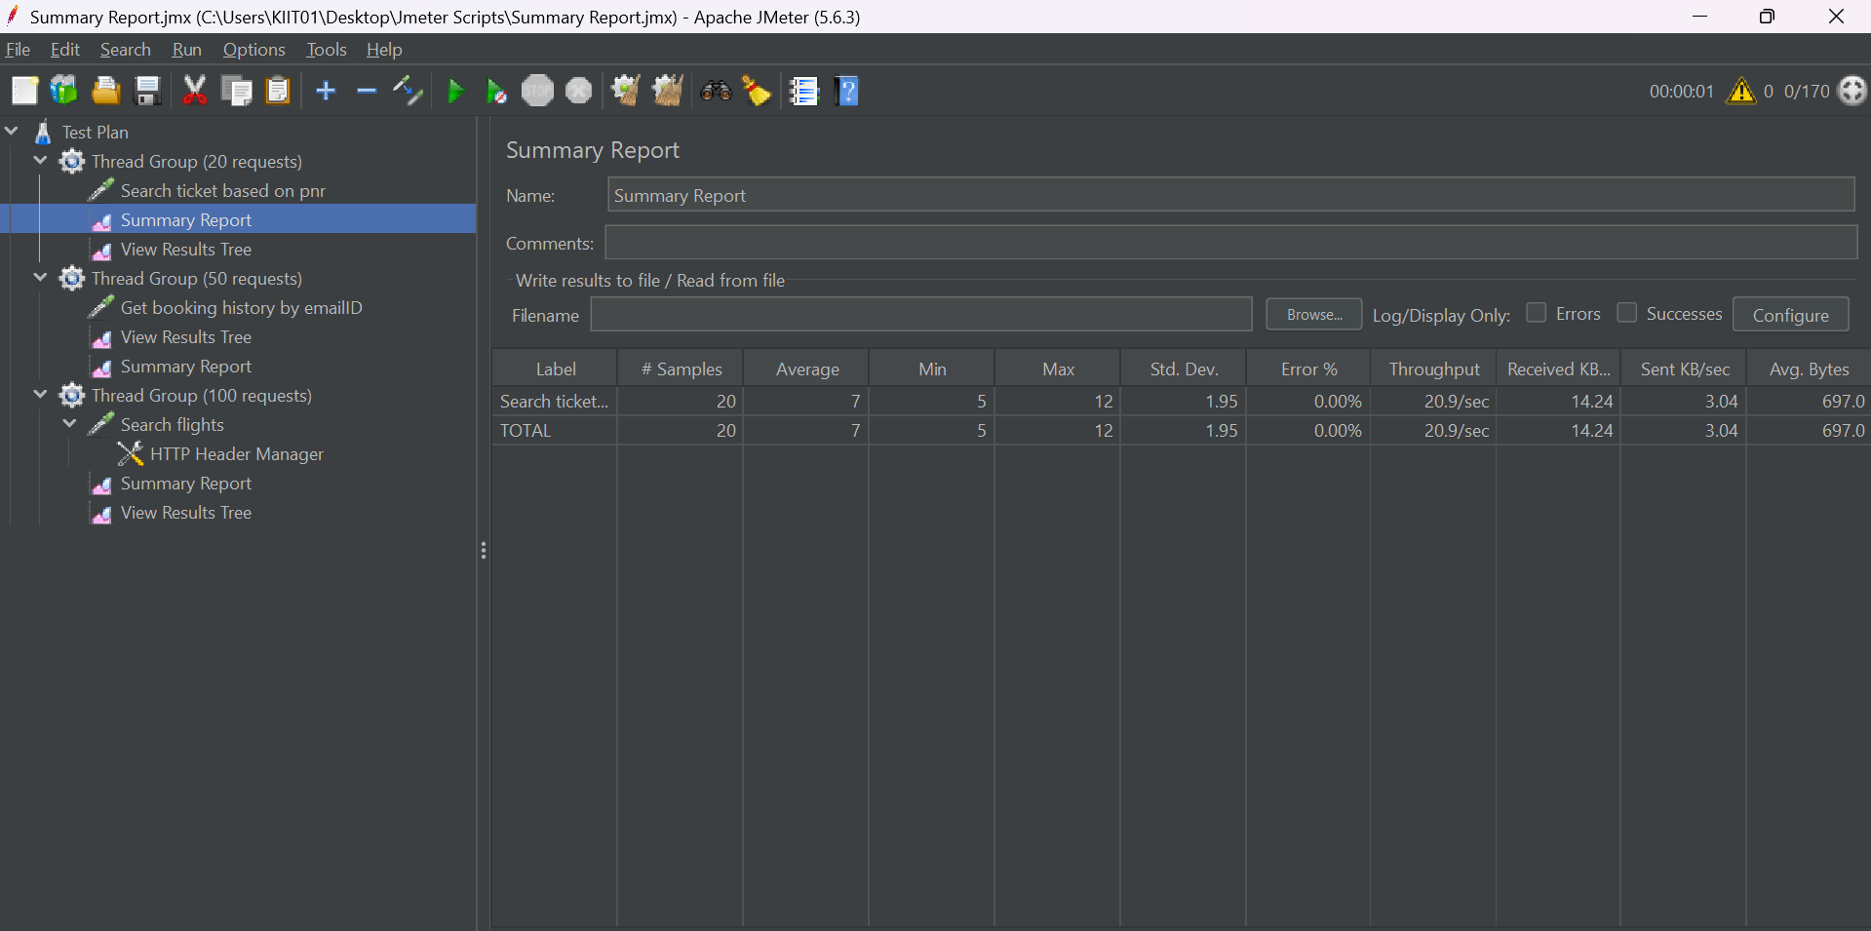

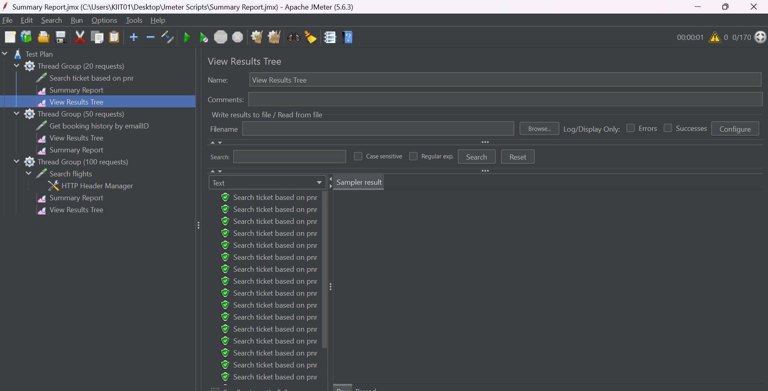

Case 2: 50 requests

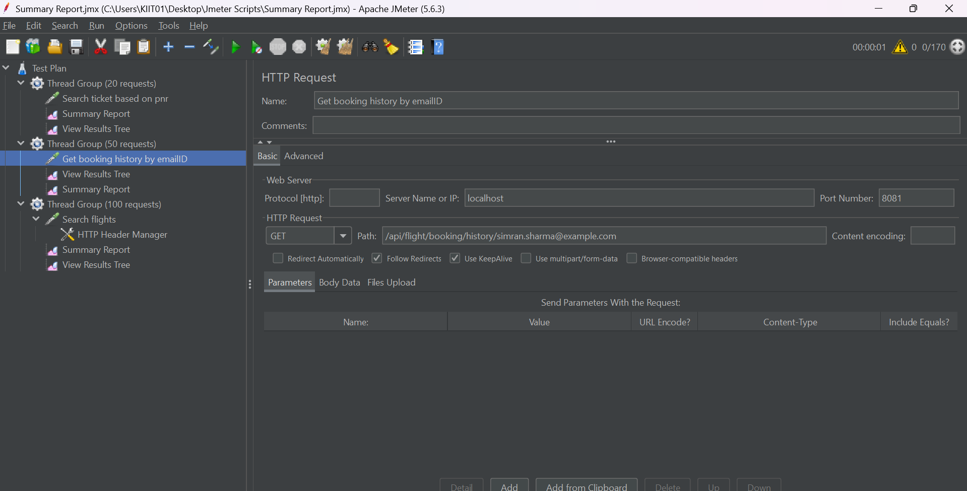

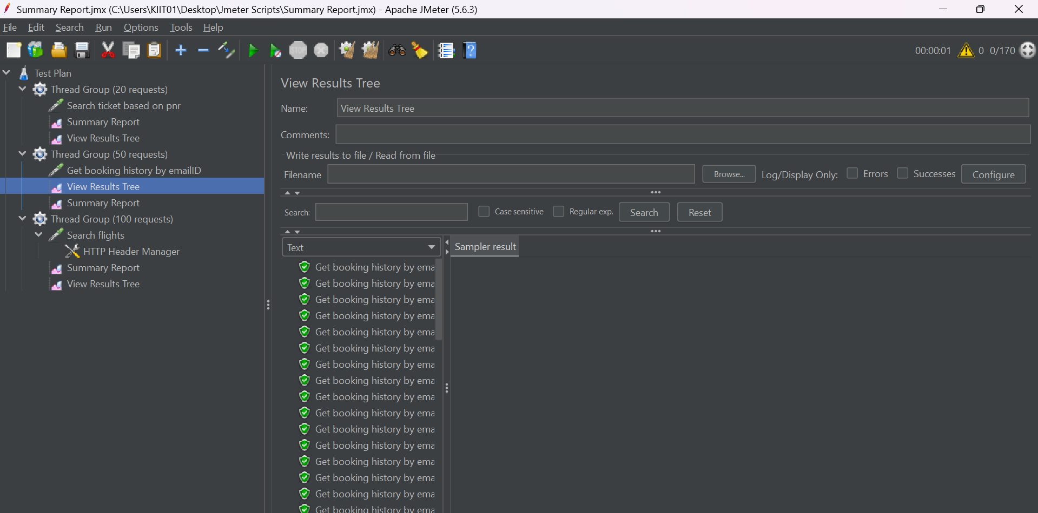

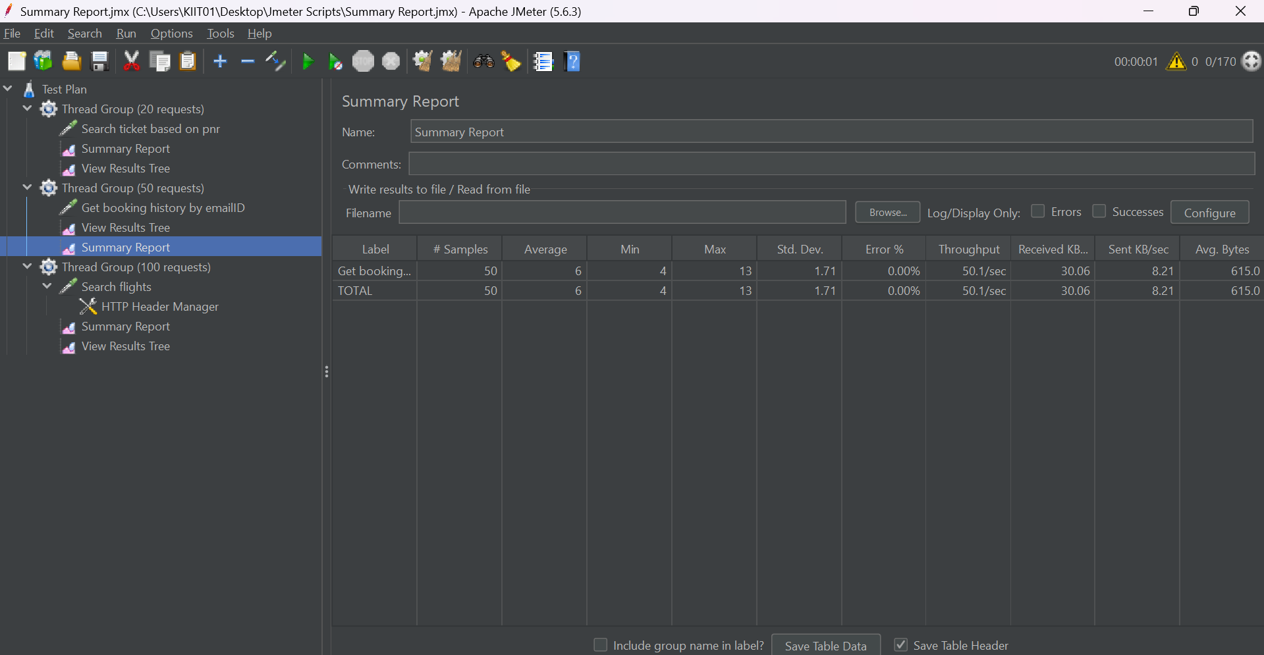

Case 3: 100 requests

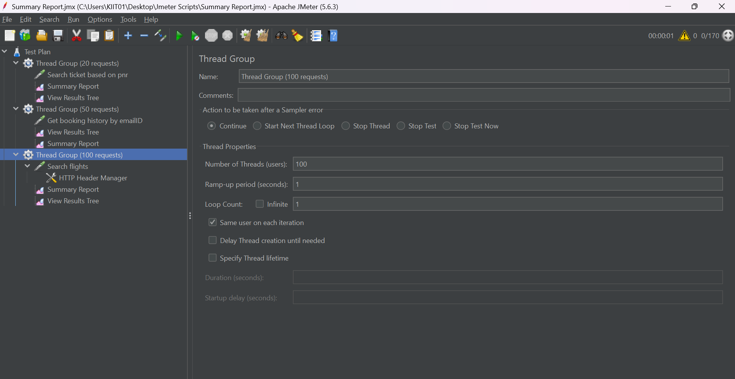

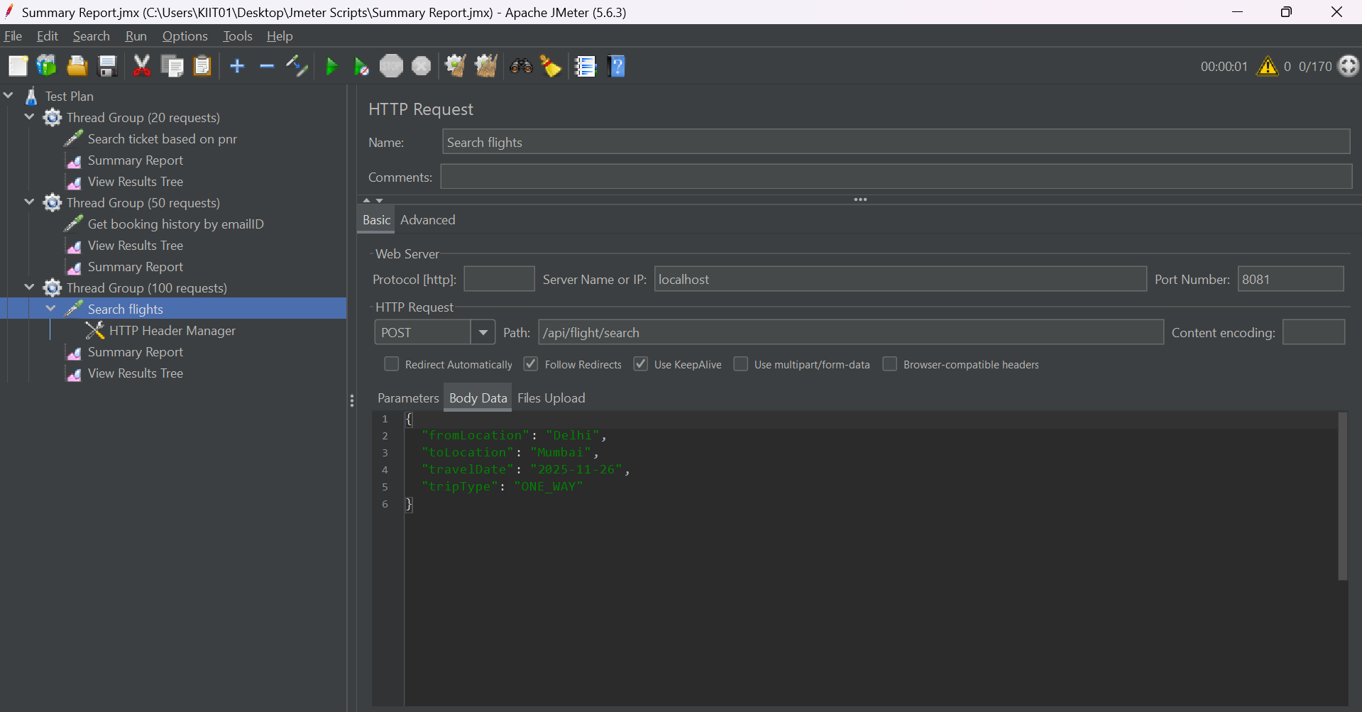

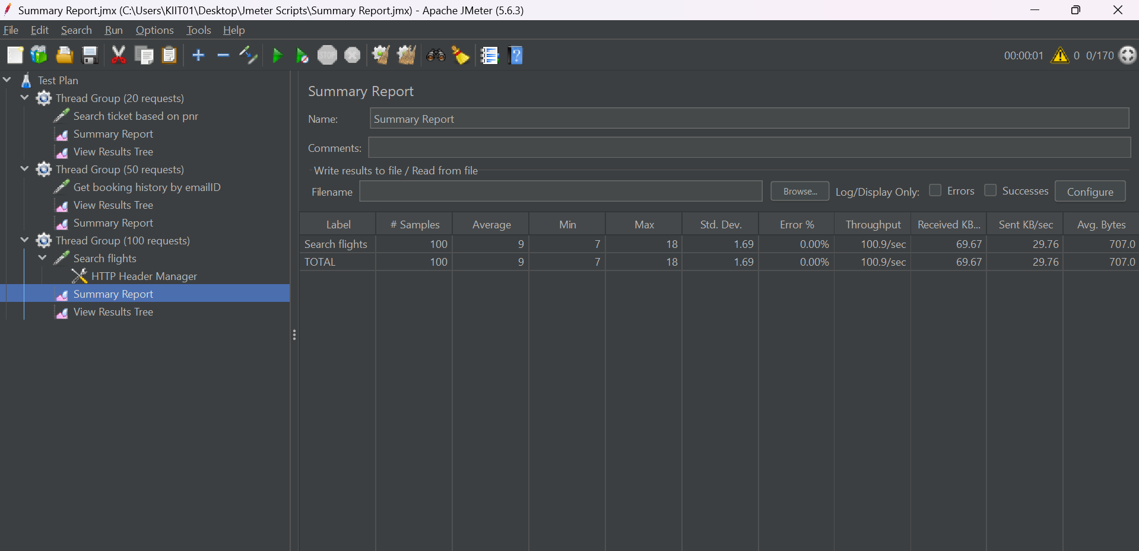

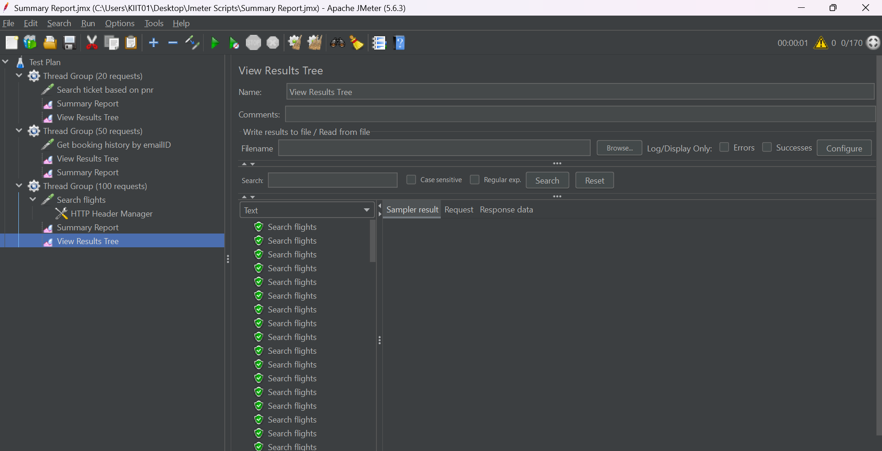

**POSTMAN API ENDPOINT TESTING**

**1. POST:**

http://localhost:8081/api/flight/airline/inventory

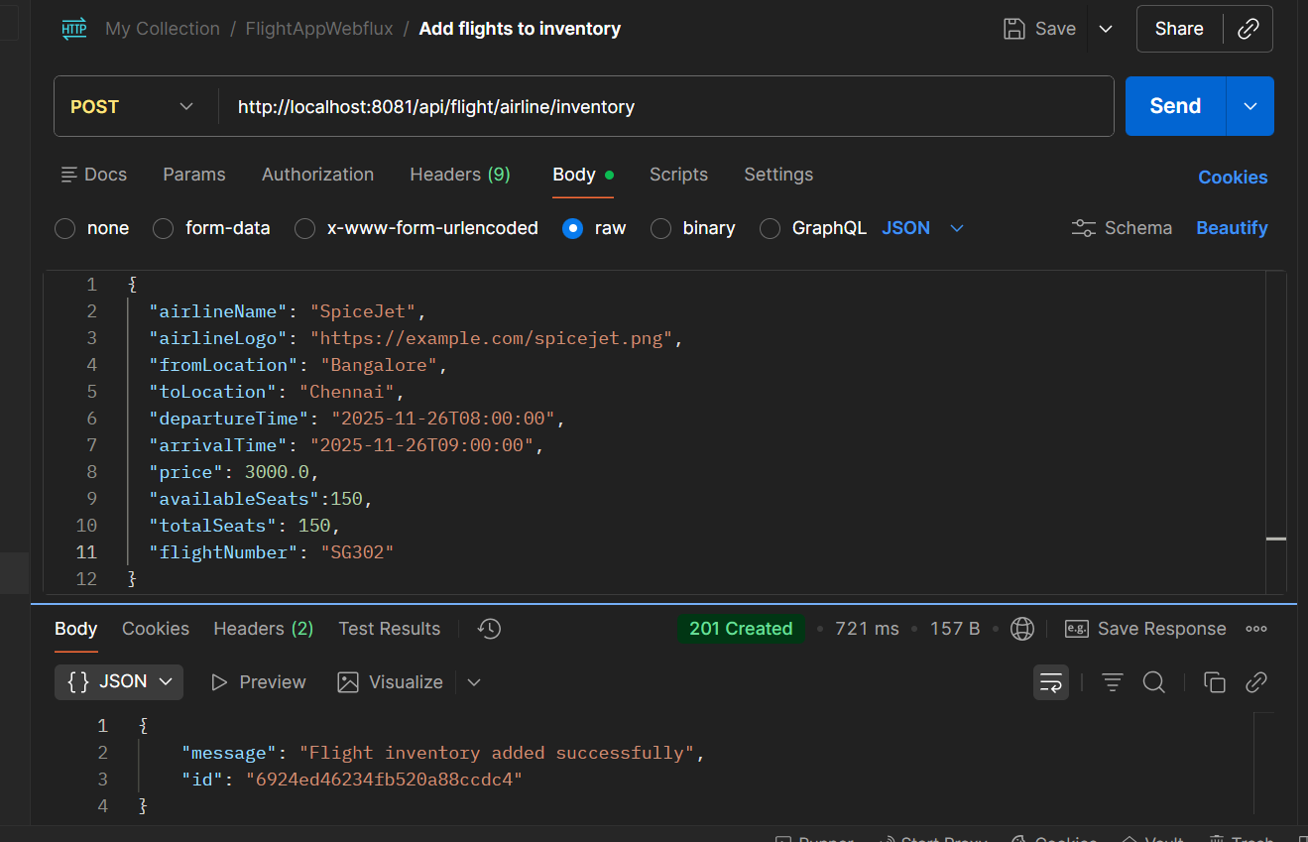

**2. POST:**

http://localhost:8081/api/flight/search

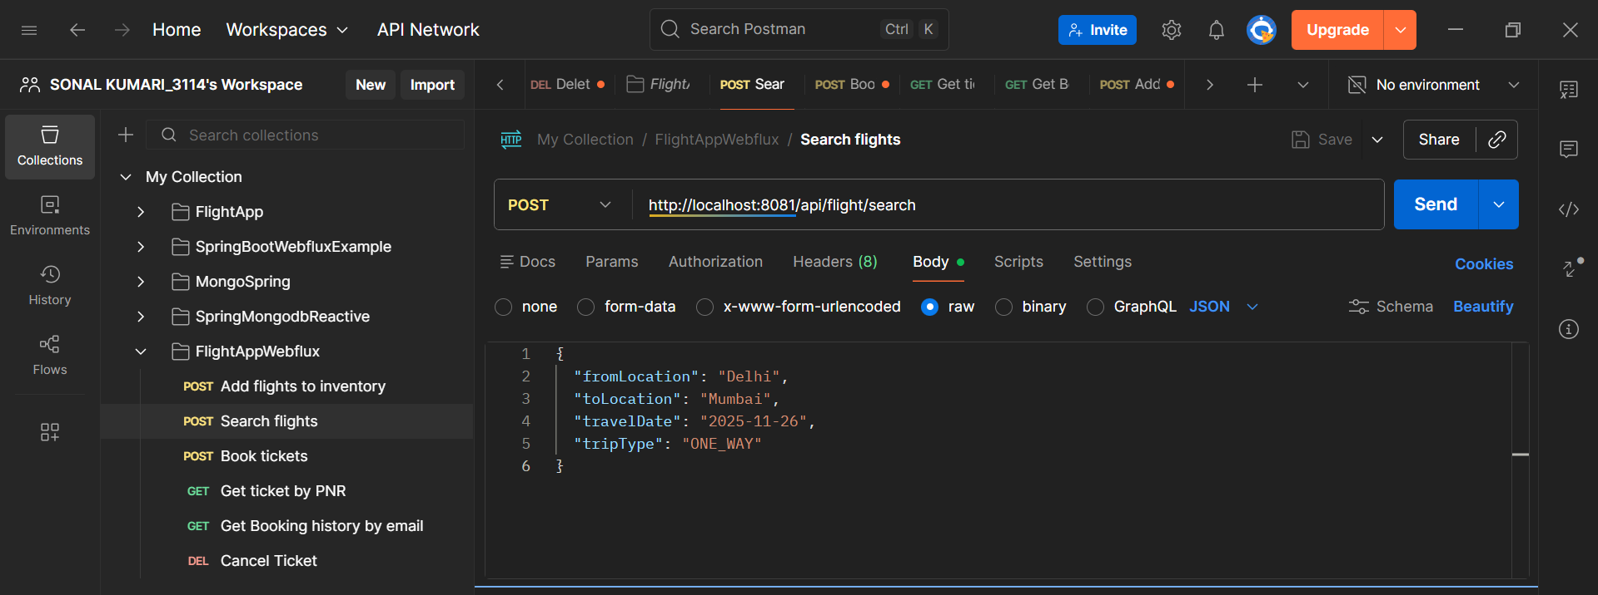

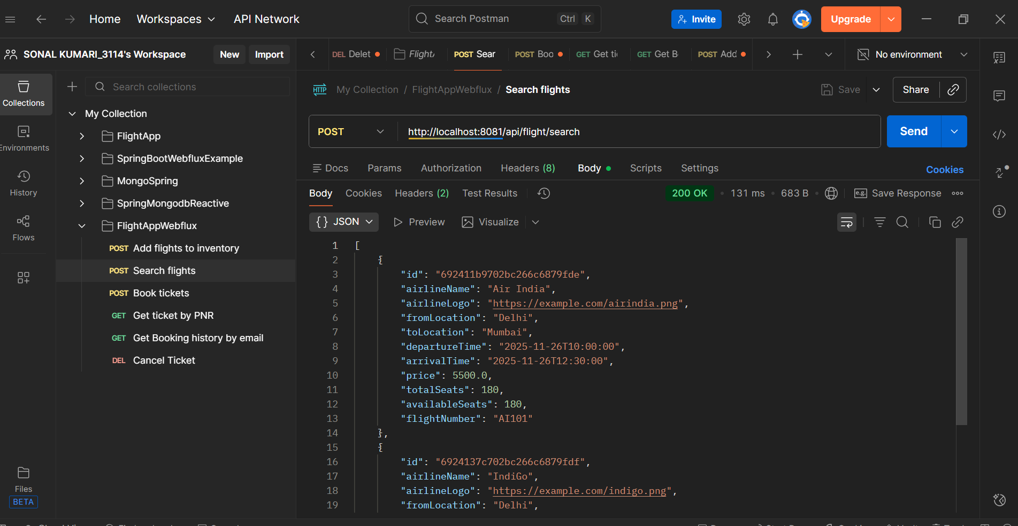

**3. POST:**

<http://localhost:8081/api/flight/booking/692413c1702bc266c6879fe0>

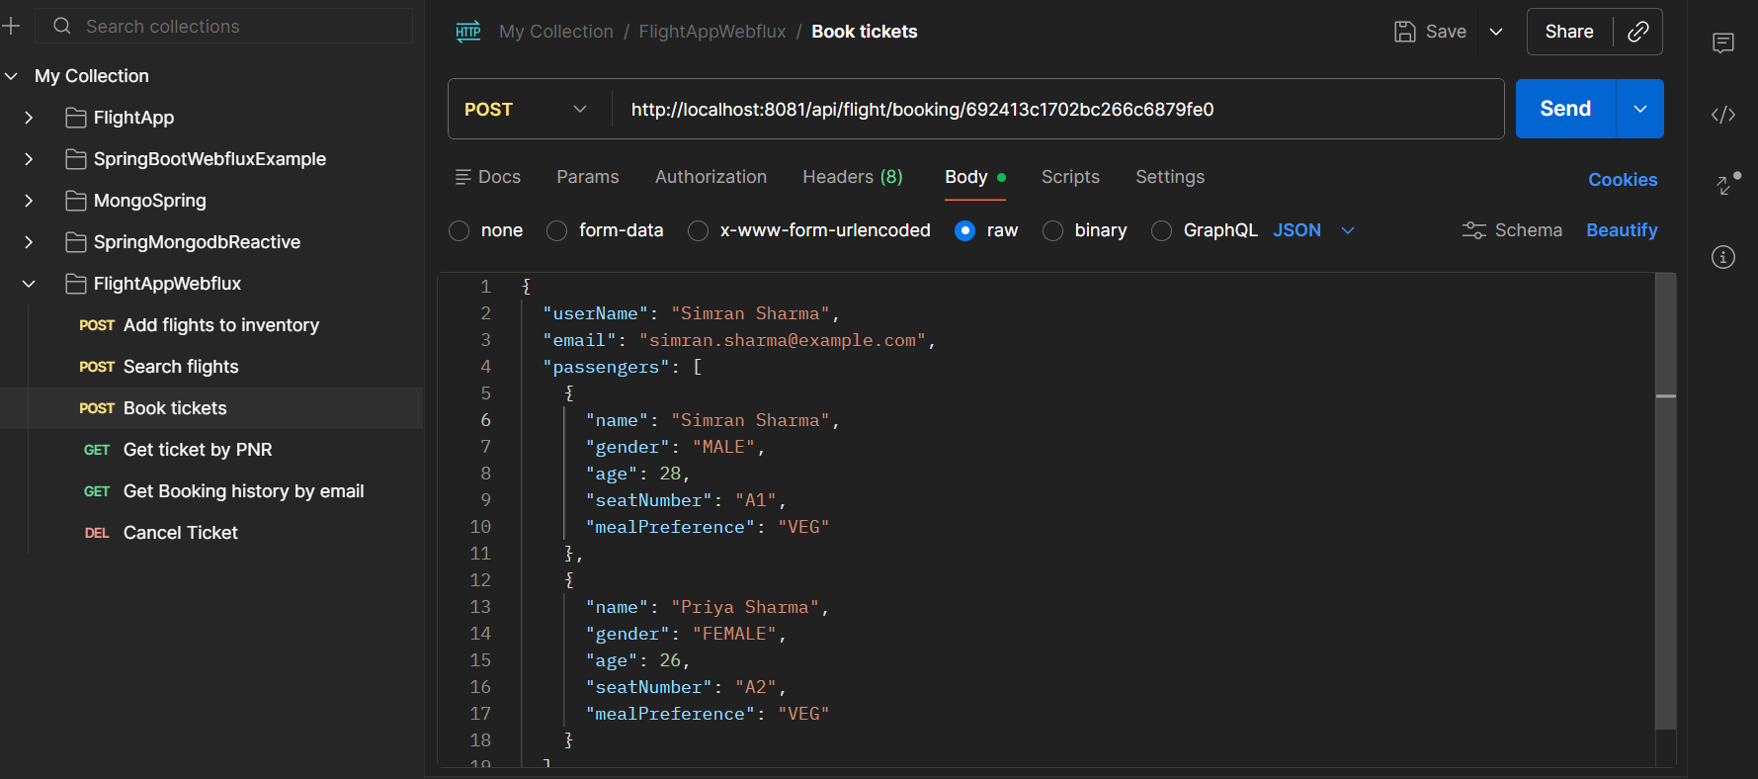

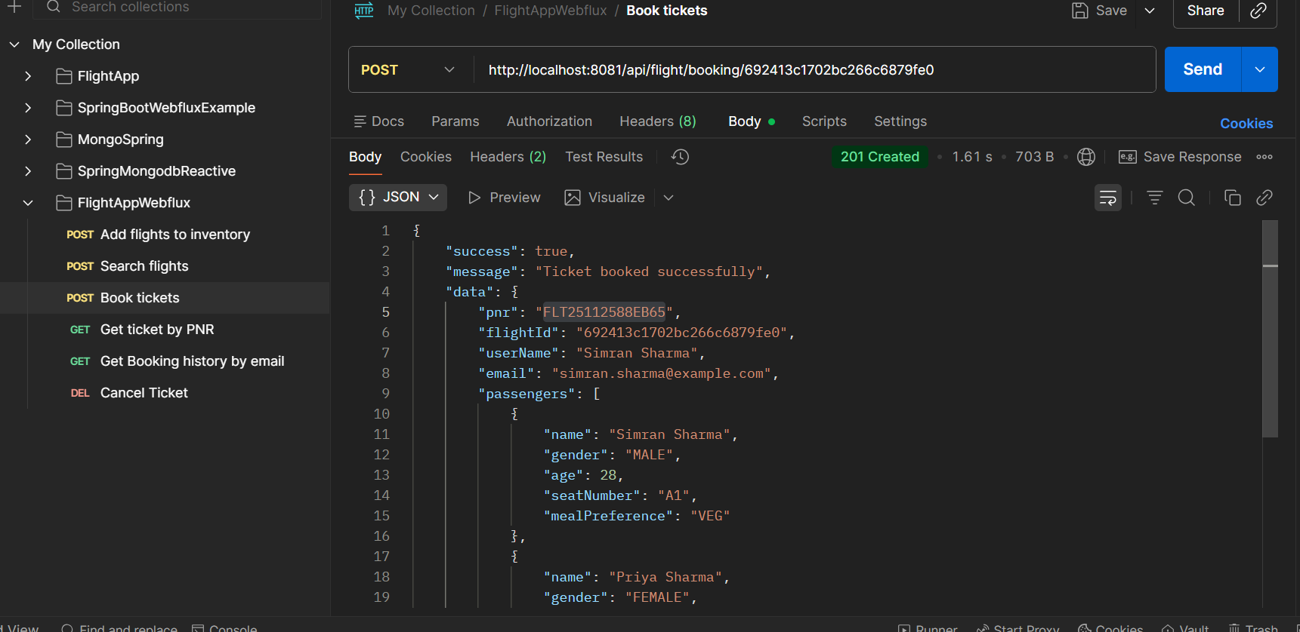

**4. GET: http://localhost:8080/api/ﬂight/booking/ticket/FLT25112588EB65**

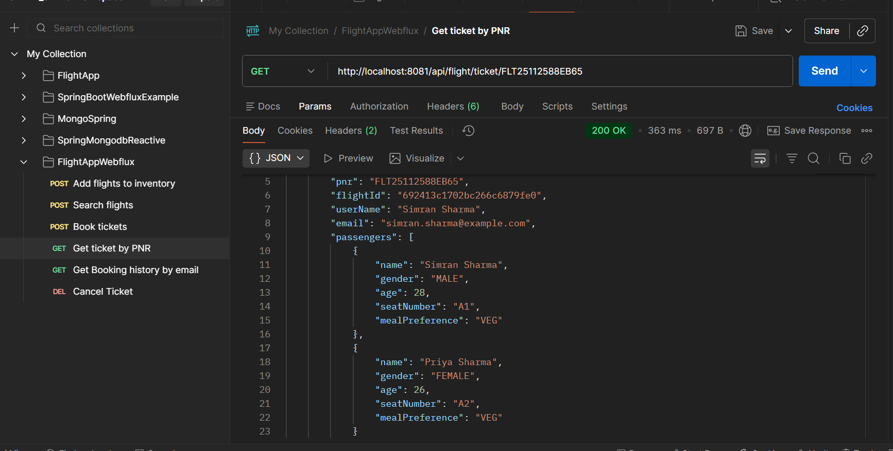

**5. GET:**

[**http://localhost:8080/api/ﬂight/booking/history/**](http://localhost:8080/api/%EF%AC%82ight/booking/history/)

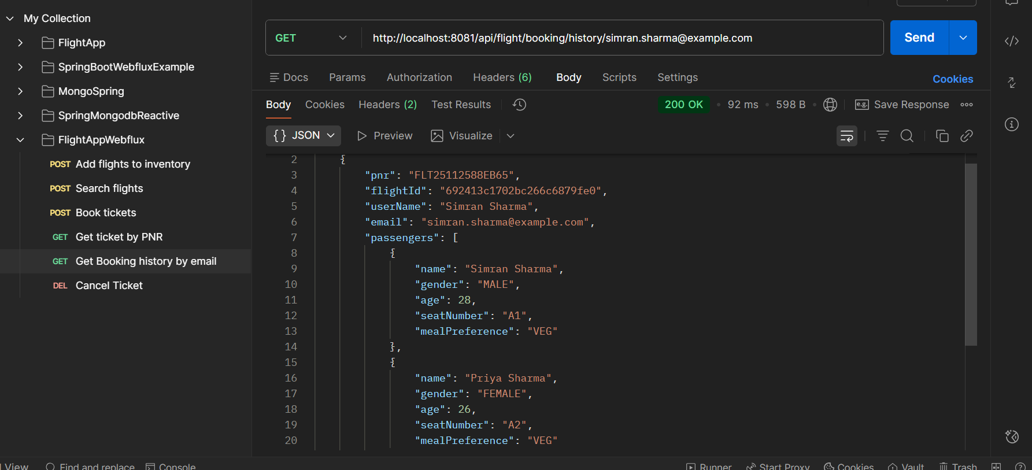

**6. DELETE: http://localhost:8080/api/ﬂight/booking/cancel/FLT25112588EB65**

